# Business Intelligence & Business Analytics Project

WALLMART

# Maheswar Gounipalli-19147848

Contents

**1. Background Information 3**

**2. Marketplace 3**

**3. Scope of processes 3**

**4. System Design 4**

**4.1. Process diagram 4**

**5. Data Capture Point: 6**

**6. Analytics Requirement: 6**

**7. Customer Integration: 7**

**8. Database Design: 7**

**a. Entity Relationship Diagram: 9**

**b. Data Dictionary: 10**

**9. Product and Customer management: 11**

**10. Creation of Test Data 12**

**11. References 15**

# 

# Background Information

What started out as a small discount shop and the basic concept of selling more for less has become the largest retailer worldwide over the past 50 years. About 11500 shops in 56 banners in 27 countries and e- websites visit approximately 265 million customers and members every week. Walmart has more than 2.2 million employees worldwide, with sales from 2020 amounting to $524 billion. Walmart is a pioneer in sustainability, corporate philanthropy and work prospects. It is part of our unwavering dedication to development and promotion of opportunities for customers and communities all over the world. [website]

# Marketplace

The core of our approach is every Day Low Price (EDLP), and our quality emphasis has never been greater. Today's customer is searching for the comfort we bring of one-stop shopping. From food and entertainment to sporting goods and crafts, we provide our consumers with the broad range they enjoy — whether shopping online at Walmart.com, via one of our mobile devices, or shopping in a store. We currently operate in the U.S. three main store formats, each customized to their neighbourhood. John Furner is President & CEO of Target, the U.S. [website]

According to the Fortune Global 500 list in 2019, Walmart is the world's largest sales company with US$ 514,405 billion. It is also the world's biggest private employer with 2,2 million employees. This is a publicly held family- corporation, since the company is managed by the Walton family. Sam Walton's descendants own more than 50 percent of Walmart through their investment company Walton Companies and their private interests. Walmart became the biggest U.S. food store in 2019, and 65 percent of Walmart's US$ 510.329 billion revenue came from U.S. operations. [wiki]

# Scope of processes

As part of our solution, we seek to regularize aspects of different processes involved in a process involving business to customer or business to company.

1. Customer Feedback Process

When a customer wants to drop a comment related to this at some point after buying the product, he / she will require visiting the store from which they purchased the product.

We plan to automate the process where various feedback forms will be mailed to the customer at different intervals after purchase.

Nevertheless, these feedbacks don't always hit the real producer and retailer. Our solution includes flows that would channel accepted feedback to the suppliers and store their responses within the program.

1. Loyalty Cards

Dependability cards give the customers benefits provided by advertising various discounts and rebates to the card holders. Our arrangement points to view this as a handle accomplished for superior scope within the CRM system.

1. Balance score cards

*The balanced approach to the score card is a valuable method for defining strategic action plans for most organizations. The balanced approach to the score card helps match critical performance metrics with the firm's plan. For instance, in the case of Wal- avoiding discrimination is related to consumers 'shopping experience. The rational approach to the score card lets the management get a view of company activities from a bird's perspective. This allows coordination and understanding of market goals and plans. In Wal-'s case it helps to articulate priorities in each region and encourages the organization to focus on those areas. The rational approach to the score card helps turn strategy into practice.*

**Database Design:**

Database design organise the data and involve the relationship among entities, it improves the data consistency and cost effective in term of memory management. It consists of entities, relationship between entities, cardinalities of relationship and integrity constraint. It encourages the structuring, advancement, upkeep and execution of the enterprise data management.

1. Customer table: It contains the customer details who visit the store and it store the information like customer name, mobile no., email address, gender, payment details and relationship to other tables in database.
2. Employee table: This table store the personal details of employee who work in Walmart store and which provide the information about customer served by which employee.
3. Payment table: It contains the information about transaction completed at store and related customer to that transaction. It also displays the type of payment made by customer.
4. Department table: Walmart store covers the multiple department and this table contains information about its unique id and name which is further classify into the multiple product.
5. Product table: It provide the collection of different products and available in stores and its quantity. Also mentions the product name and relationship to the departments.
6. Store table: It contains information about stores which are available in different countries.
7. Gift Card table: Walmart provide the facilities to the customer to buy a gift card and send to relatives, friends, family etc. to do shopping. This table store all the information of gift card related to product and customer.
8. Loyalty Point: For every purchasing Walmart provide its customer loyalty point to build the relationship with its customer and to those who are frequent buyer. Table displays the number of point and related customer to it.

**Entity Relationship Diagram:**

ER diagram display the logical structure of database and relationship between the entities. An entity contains different attribute, which define its properties. There are main 5 component of ER diagram that are entity, actions, attributes, connecting lines and cardinality. It displays the same information as database design, but representation is different as:

1. Entity: It is same as the table name like customer, product, employee etc and the graphical representation of entity is rectangle.

Entity

1. Action: which is represented as diamond shape and display the relation between entities.

Relationship

1. Attributes: It display the characteristics of entity and represent in shape of ovals.
2. Connecting line: Used to represent the relationship of entities and connection to attribute with solid line.
3. Cardinality: It provide the details of the relationship between multiple entities in terms of instances like one to one, one to many and many to many relationships.

Following is the mentioned database design which reflect the relationship between tables and their column details:

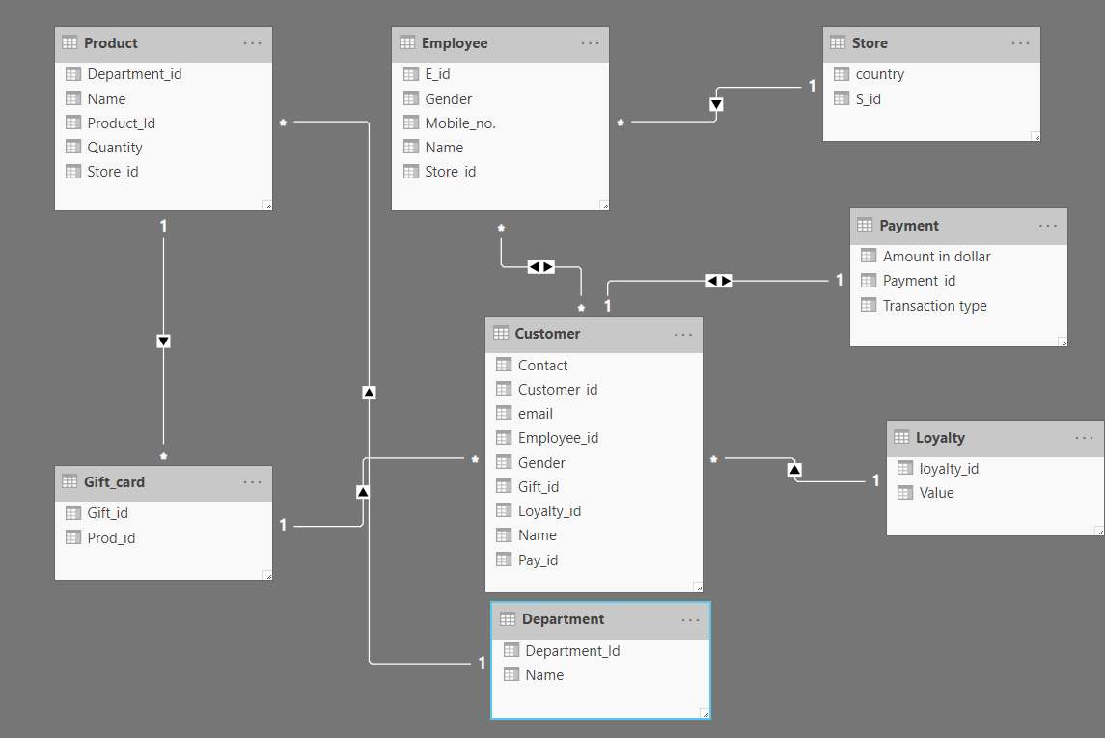

**Figure: Database design in power BI**

**Process Flow (Life Cycle):**

* Walmart receive product from manufacturing company and distribute to stores through supply chain management.
* Customer visit the store and who do not buy any product will fill the feedback form at exit gate and who bought any product will fill the feedback at billing counter about the services provide by Walmart.
* Employee check the loyalty point of customer, if available they ask for redemption or carry forward, if customer do not have any loyalty point employee look for any gift card available if not then employee provide the Walmart promotional offers to the customer.
* Customer pay the bill based on eligible offers and provide the feedback about the store services as mentioned above.
* Online feedback form will be sent to customer to receive the feedback about store services and product quality.
* Feedback related to store received by store manager and if it feels suitable to improve the store services, it will forward to support team and they will apply those updates in the system and acknowledgement will sent to customer.
* Feedback related to product quality received by sales team and if it’s a genuine case, it will forward to management team.
* Management team study the case and take the appropriate action with respect to Walmart policy and forward it to supplier. If any update required according to supplier then it will be update in system by support team and acknowledgment will be sent to customer else case close.

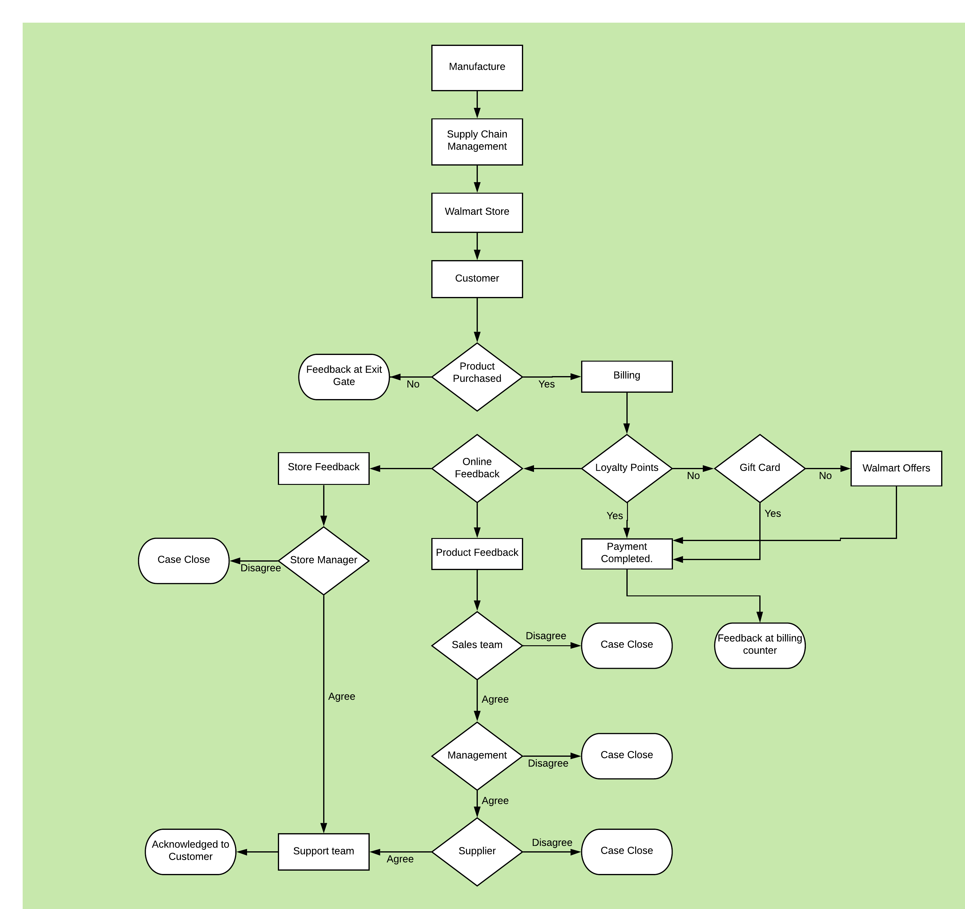

**Customer Feedback Flow**

**Product Flow**

**Figure: Process flow diagram of product and customer feedback**

# System Design:

System design is process of describing the actual flow, interface and data, in this level the collaboration of requirement are done in order to optimise the challenges. This challenge can be processed in parts using divide and conquer method to overcome the challenge. We can categorise the tasks respectively and split into different department to fetch actual challenge.

System Design

Implement CRM

Implement Power BI

Manage Data

Identify Goals

Steps:

* Date flow process and the outputs generated by logic implemented in the system. From analyst’s perspective, logical design should cover all the challenges which needs to be worked on during implementation phase.
* Here the feedback or review needs to be gathered into a data through customers input and system generated output will be saved in data and few tasks will be performed accordingly, transforming data, feeding data to platforms used, drawing insights, etc. It ensures that an efficient working system exists.
* Architectural design is related to the structure and behaviour of the system. It indicates the genre where the deviation is happening from expected behaviour.
* Conceptual data models is develop a skull of backend services of a system and analyse the areas where improvement can be drawn. The data for this loopholes can be fetched from various sources such as feedback and internet surveys.

# Analytics Requirements

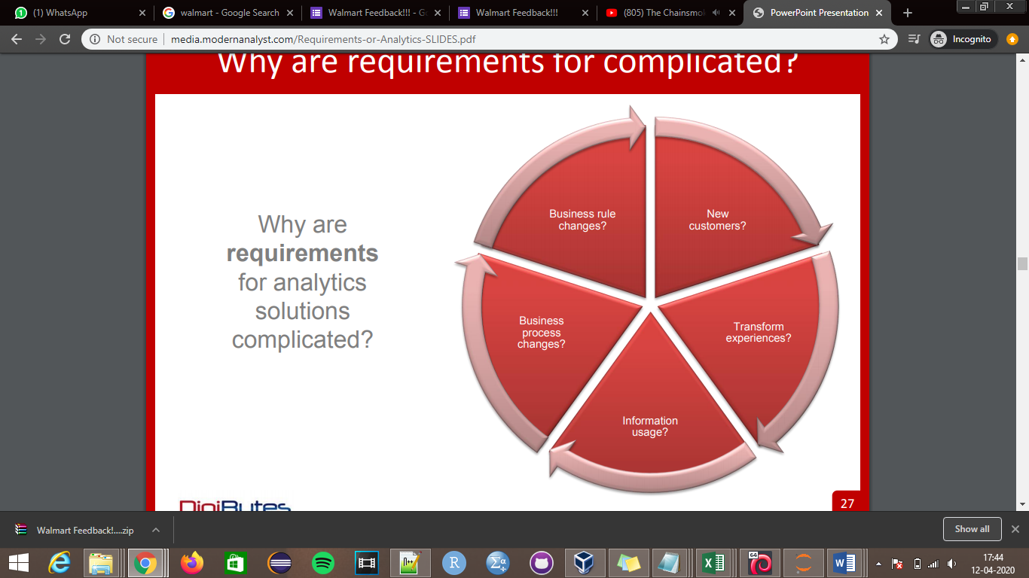

These requirements are generally taken in consideration when **new costumers** notice any issue or situation and when it comes to organisation’s attention by feedback or review given by the customers which is **transform experience.** This information is stored into organisation’s databases and later the respective team would draw **changes in process with respect to information used**. Once the business rules changes the response starts reflecting in the business.

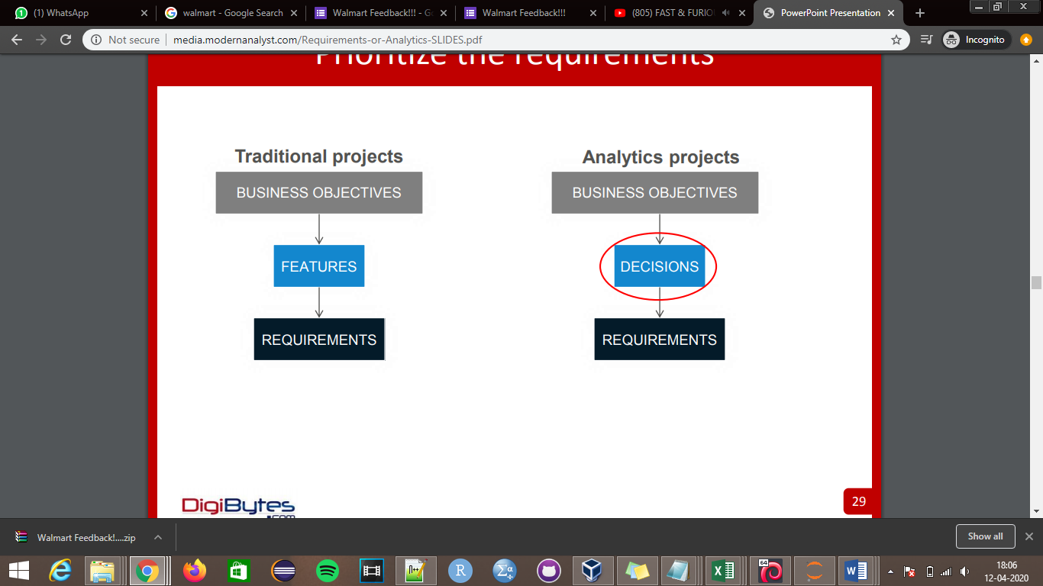

* The business motive is to take decisions smartly based on the requirement instead of providing with lot of features to customers to achieve the expected target or objective.

# Customer integration for solution

Customer Data Integration (CDI) is a procedure to maintain the information about the customers from every feasible way or sources like social media, feedback forms, registrations.

Coming customers responses the organisations came up with interface operations towards customers where customers can access all the benefits given by the organisation to the products and which will be reflected dynamically and customers would be provided with lot of other services such as keeping a track or supplier as well as deliveries and quality and can also take decision by going through the review of feedbacks given by other customers. In case of help the organisations are providing help centre to keep customers on track.